A short summary covering: top state by sales, top category by revenue, top brand by sales, and the purpose of cache/persist, broadcast joins, and repartitioning.
Solution
- The analysis identified the top-performing state by total sales, helping the business understand which region generates the highest revenue.

- The top revenue-generating category showed which product segment contributes most to overall business growth.

- The top brand by sales highlighted the most popular and highest-performing brand among customers.

- Caching/Persisting improved performance by storing the frequently used joined DataFrame in memory, avoiding repeated computations.

- Broadcast joins optimized joins by sending the smaller products table to all worker nodes, reducing expensive data shuffling.

- Repartitioning by state improved parallel processing and made regional analysis faster and more efficient.

- Writing the final output in Parquet format provided efficient storage and faster analytical querying in Spark.

Screenshots of important outputs and result tables.
- Row counts of datasets
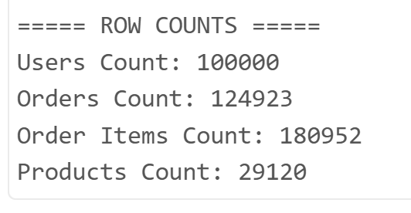

- Null value checks and cleaned outputs
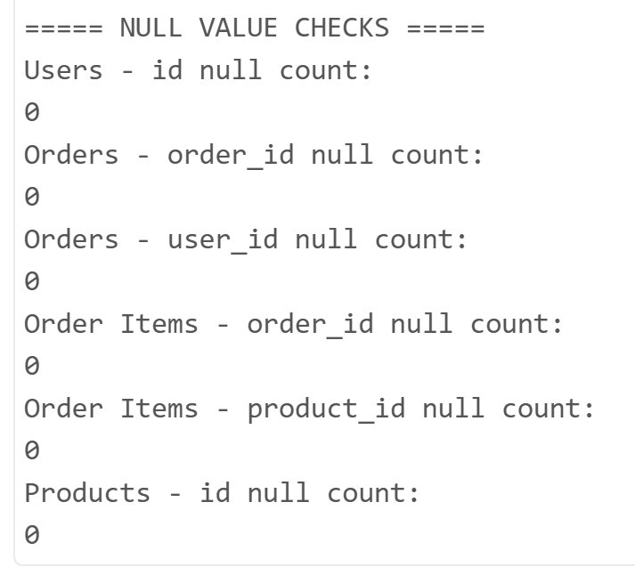

- price_bucket transformation results
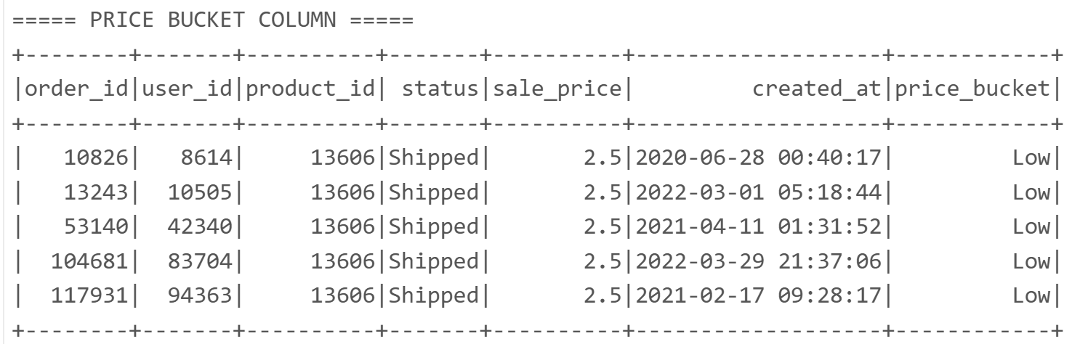

- Top 10 categories by items sold
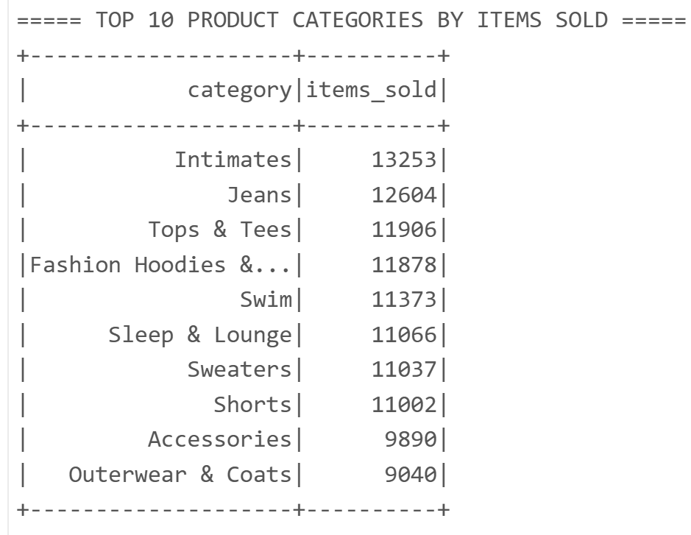

- Top 10 brands by total sales
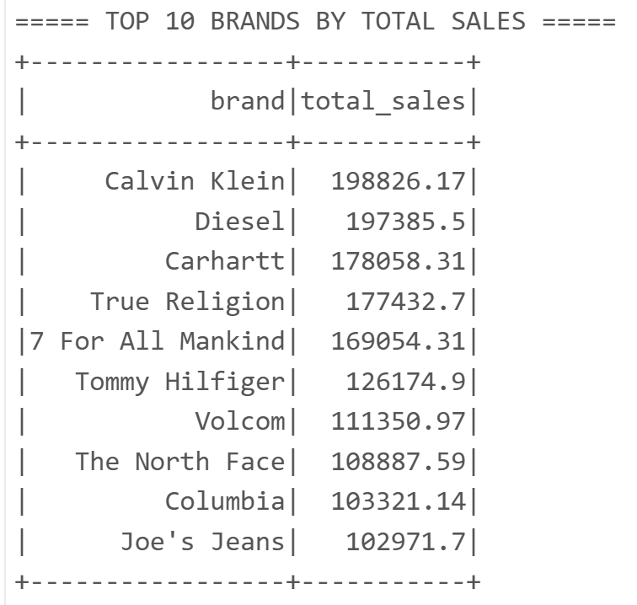

- Top 10 states by sales/orders
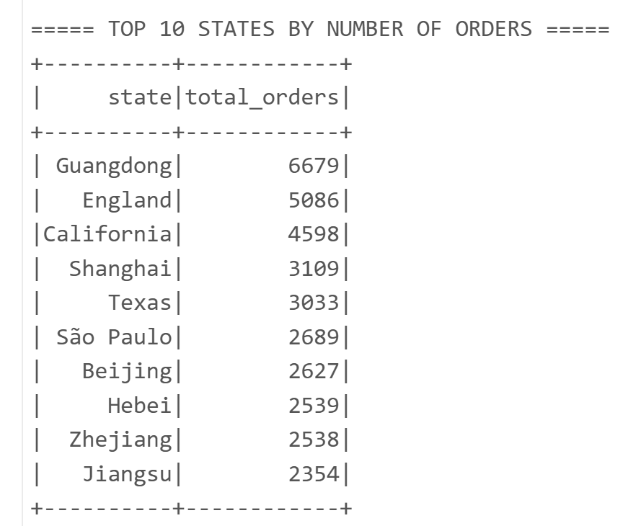

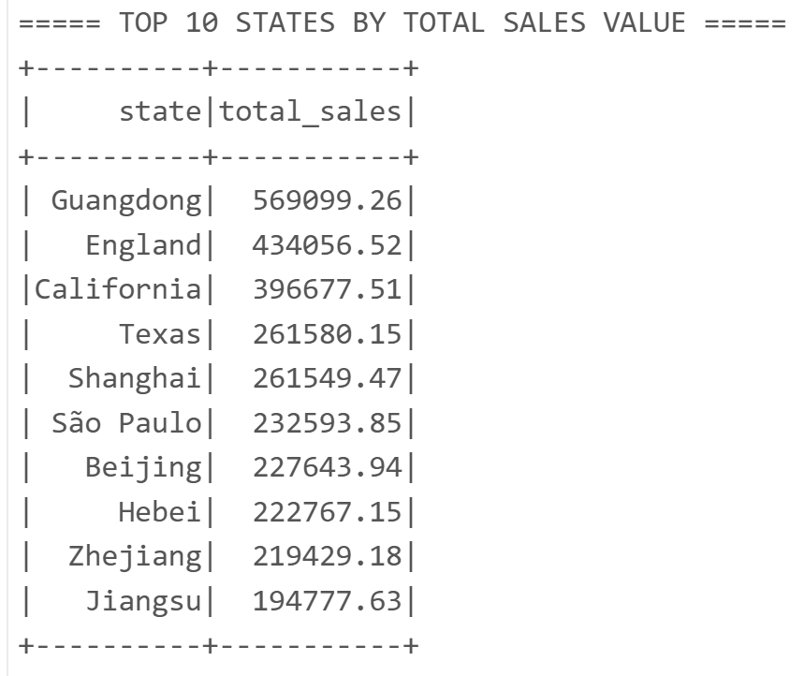

- Average sale price by category
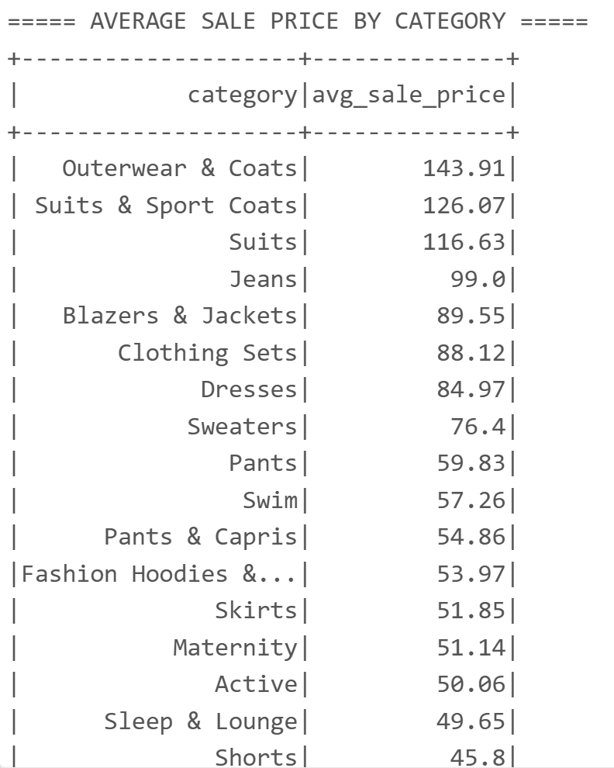

- Status counts (completed/returned/cancelled)
